8 November 2022

WAR SIMULATOR

REPORT

404 Not Found

**COS 214 PROJECT**

Shiluvelo Makhubele u19086352 .

Christof Steyn u17021074 .

Charl Volschenk u17053928 .

Rebecca Oosthuizen u20512008 .

Chris Mittendorf u15092462 .

Akani Hlungwani u19240202 .

Introduction

In this project, we were tasked to design and construct a war simulator software system using the design patterns identified by Gamma et al [1] .

Research Findings

We found the following information through research and pre-existing knowledge about warfare:

Warfare

Warfare concerns two or more opposing parties engaging in armed conflict with one another. Warfare occurs for one or more of a variety of reasons.

War Theatre

Inspired by von Clausewitz’ definition of “theater of war” [3] , we define a war theatre as an area in which a battle between alliances takes place. The area type can be airspace, land, or sea, which affects the type of unit that can be deployed into the theatre. For example, airplanes can only be used in an airspace.

Entities

There are various entities belonging to countries that can be deployed into a war theatre to engage in warfare. The entities we will use in our implementation are as follows:

**Person:**

A person can be a soldier (actively participates in battle by causing and taking damage), a medic (heals wounded soldiers), or a mechanic (repairs damaged vehicles).

**Vehicle:**

A vehicle can be a tank (deployed in land war theatres), a plane (deployed in airspace war theatres), or a ship (deployed in sea war theatres).

Phases of War

A war itself can be broken into a variety of phases. We have decided to consider the following phases, inspired by Bloomfield [2], in our implementation:

**Phase 1**: Dispute

A dispute takes place between countries.

**Phase 2**: Conflict

The countries involved in the dispute form alliances.

**Phase 3**: Fighting

In this phase there is direct conflict between the alliances.

**Phase 4**: Post-Conflict

Direct fighting between alliances stops but the conflict has not yet ended. Negotiations between alliances take place in an attempt to end the conflict.

**Phase 5**: Diplomacy

This is the final phase of war where the dispute is settled.

The United Nations

The UN [4] is an international organisation which 193 member states form part of. It is committed to maintaining international peace and security and will thus foster negotiations in our system.

Changes in War

Countries and alliances may change their approach to warfare as time progresses. The changes that countries and alliances are able to make in our system are as follows:

**Alliance Adjustment:**

Countries may choose to join an alliance, leave an alliance, or change alliances.

**Research and Development:**

A country or an alliance may choose to spend additional resources on research and development in order to gain extra entities or to improve their existing entities.

**War Treaties:**

Countries or alliances may adopt war treaties, such as a no-fire treaty while negotiations are taking place.

**Tactic Adjustment:**

Countries may adjust how aggressively they respond to provocation or attack. For example, if a country has depleted resources, another alliance may choose not to attack it.

Application

The above research findings will be implemented and use design patterns [1] in the system in the following ways:

Warfare

Our system will model various elements of a turn-based war taking place between two opposing alliances or country groups. The reasons for war will not be taken into consideration in our simulation. We will only model the occurrences within actual warfare.

**Simulator Mode**

The user can run the program in two different modes:

*Design mode:* The program will accept all inputs from the user and will allow the user to interrupt the simulation, tweak it, and continue.

*Real mode:* The simulation will be set up and run uninterrupted.

The Memento Design pattern will be used to save the state of the entire simulation upon user interrupts in design mode. This is in case the user wishes to pause the program or if there is a system crash so that the saved state can be restored.

*Figure 1: Activity Diagram of Mode Selection*

**War Engine**

The main driver of our simulation will be an event loop referred to as the war engine. This loop contains a country group’s ‘turn’ (consisting of attacking another country and resource management) and will continue until the diplomacy phase is reached.

The Singleton design pattern will be used to create a single instance of the war engine as there should only be one instance of this class.

War Theatre

The war theatre will be classified as a land space, sea space, or air space, which will dictate the types of units that may enter the theatre. The war theatre will have a list of the alliances at battle, as well as an attacking squad and a defending squad. The squads can be sea squads, land squads, or air squads.

The attacking and defending squads will use the Composite design pattern so that their entities’ functions can be called simultaneously.

The Builder design pattern will be used to build the squads different types of squads.

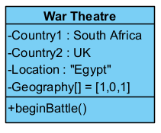

*Figure 2: War Theatre Object Diagram During Phase 3 and Phase 4*

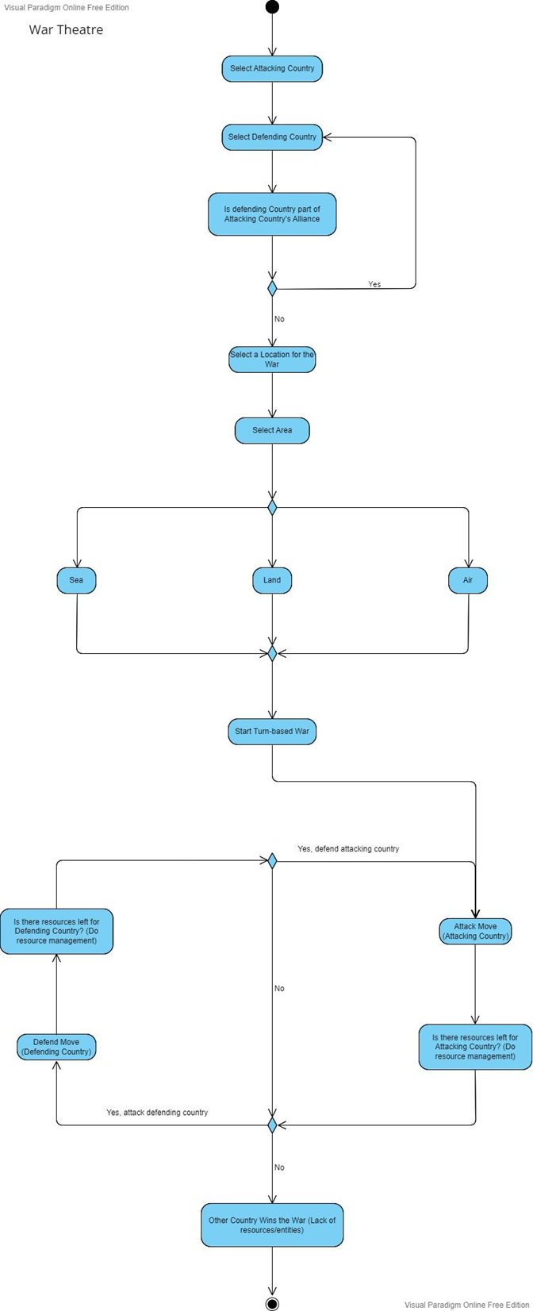

*Figure 3: War Theatre Activity Diagram*

Entities

Each country will have its own set of entities, including people (soldiers, mechanics, and medics) and vehicles (tanks, ships, and planes). In a war theatre, the entities of opposing groups compete against one another. Vehicles can only cause damage to other vehicles, and soldiers can only cause damage to other soldiers. If a unit falls below a certain health level, it is considered damaged/wounded and will need to be repaired/healed by a mechanic/medic. If a unit loses all of its health, it will be eliminated.

The Template design pattern will be used to define an interface for the entities.

The Abstract Factory design pattern will be used to produce the prototypes that are used in the creation of units.

The Prototype design pattern will be used by the AbstractFactory to create multiple instances of concrete entities.

The Memento design pattern will be used restore the original state of damaged entities once they have been attended to by a medic or mechanic.

*Figure 4: Entity Object Diagram of a Soldier and a Medic*

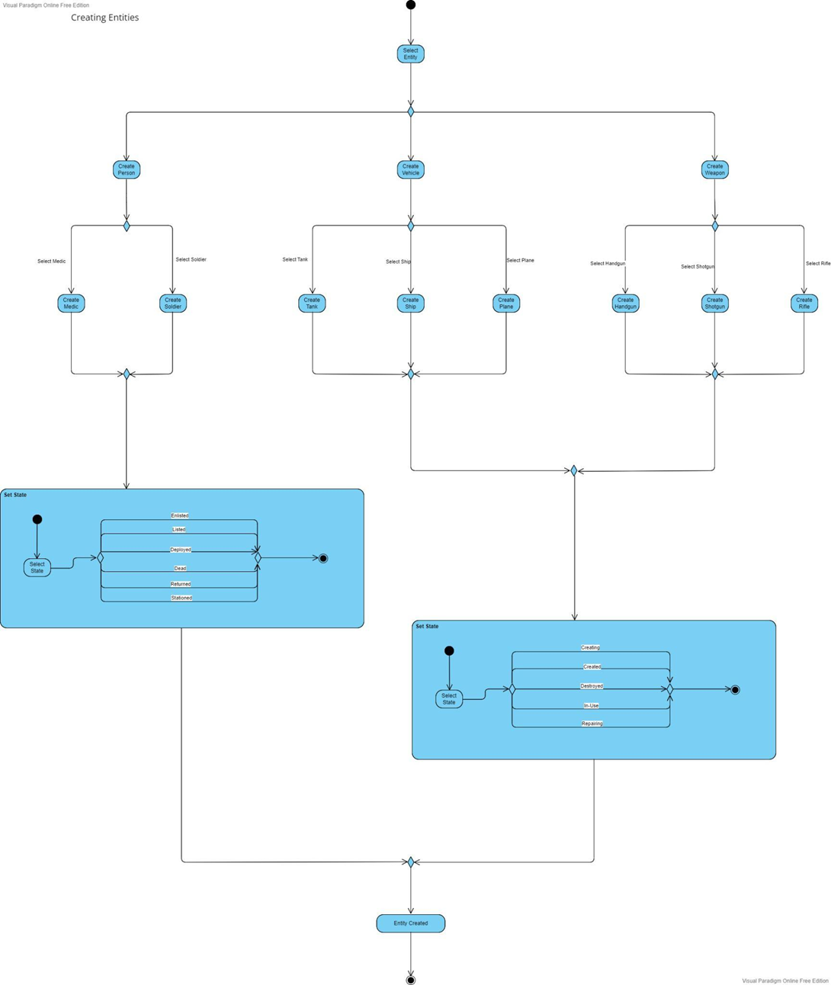

*Figure 5: Entity Creation Activity Diagram*

Phases of War

**Phase 1**: Dispute

The user specifies how many countries are involved in the conflict and how many alliances can be formed. The starting state of each country is also decided here, for example, military size and available resources.

**Phase 2**: Conflict

Alliances can be manually created by the user, or they can be randomly created by the program.

**Phase 3**: Fighting

In turn, alliances will attack and deal damage to one another. Resources can be managed before a turn ends. This entails maintenance of troops and vehicles, delivery of additional units and ammunition, and evacuation of refugees and prisoners of war.

**Phase 4**: Post-Conflict

Direct fighting ceases, but resource management still takes place and negotiations begin. This stage is entered if an alliance's units and/or resources are depleted or if they surrender. If negotiations are successful, the war progresses to Phase 5. If negotiations are unsuccessful, the war goes back to stage 3.

**Phase 5**: Diplomacy

If diplomacy is successful, the war ends. If it is unsuccessful and a new dispute arises, the war goes back to Phase 2 where alliances will be reformed, and the war will continue.

The State design pattern will be used to control the phases of war that the simulator is currently in. The states will change how the program runs and how all the entities behave depending on the state currently being used.

The Strategy design pattern will be used to define the algorithms that units use depending on the overall state of the program.

The Iterator design pattern will be used to progress through a turn in Phase 3. The iterator will step through the methods in the war theatre to produce an outcome.

The Command design pattern will be used in negotiations and diplomacy.

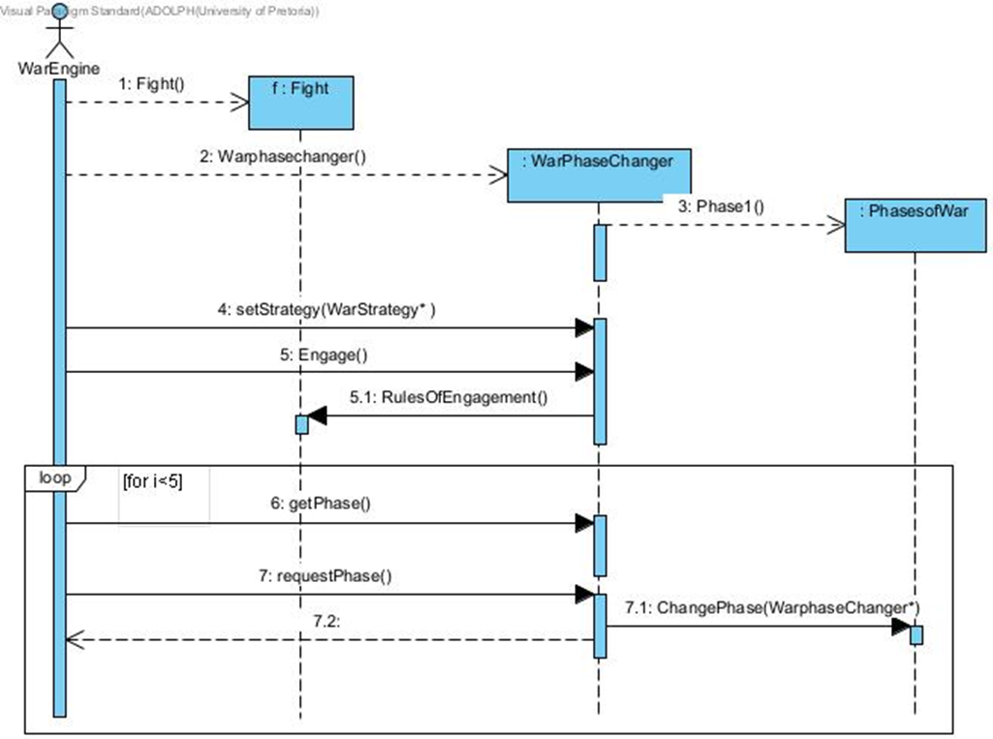

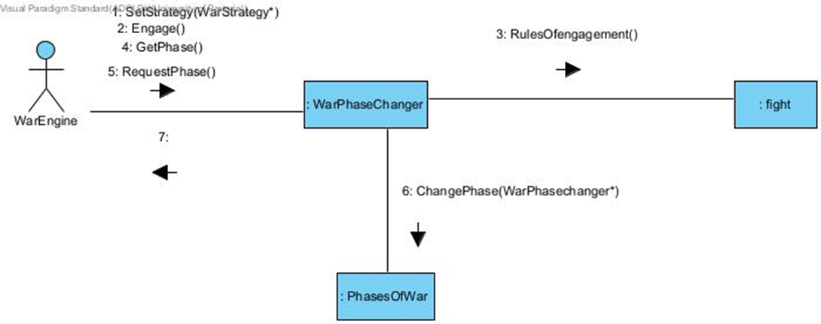

*Figure 6: Phase and Strategy Sequence and Communication Diagrams*

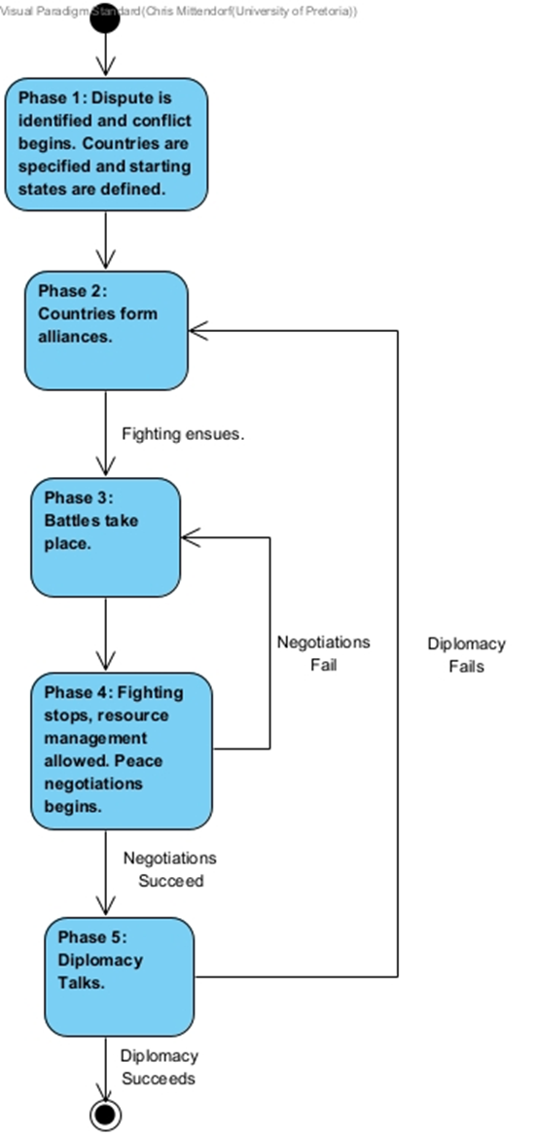

*Figure 7: State of War State Diagram*

The United Nations

In our simulation, the United Nations will be notified when war is waged and of the outcome of negotiations.

The Observer design pattern will be used to notify the UN of wars and negotiation outcomes as well as to notify and update countries when the state of their alliance changes.

Changes in War

Countries will be able to join an alliance, leave an alliance, or change alliances while the simulation is running, as well as be able to upgrade the abilities of their entities.

The Decorator design pattern will be used to add new methods and attributes to entities in order to upgrade them.

Class Diagram

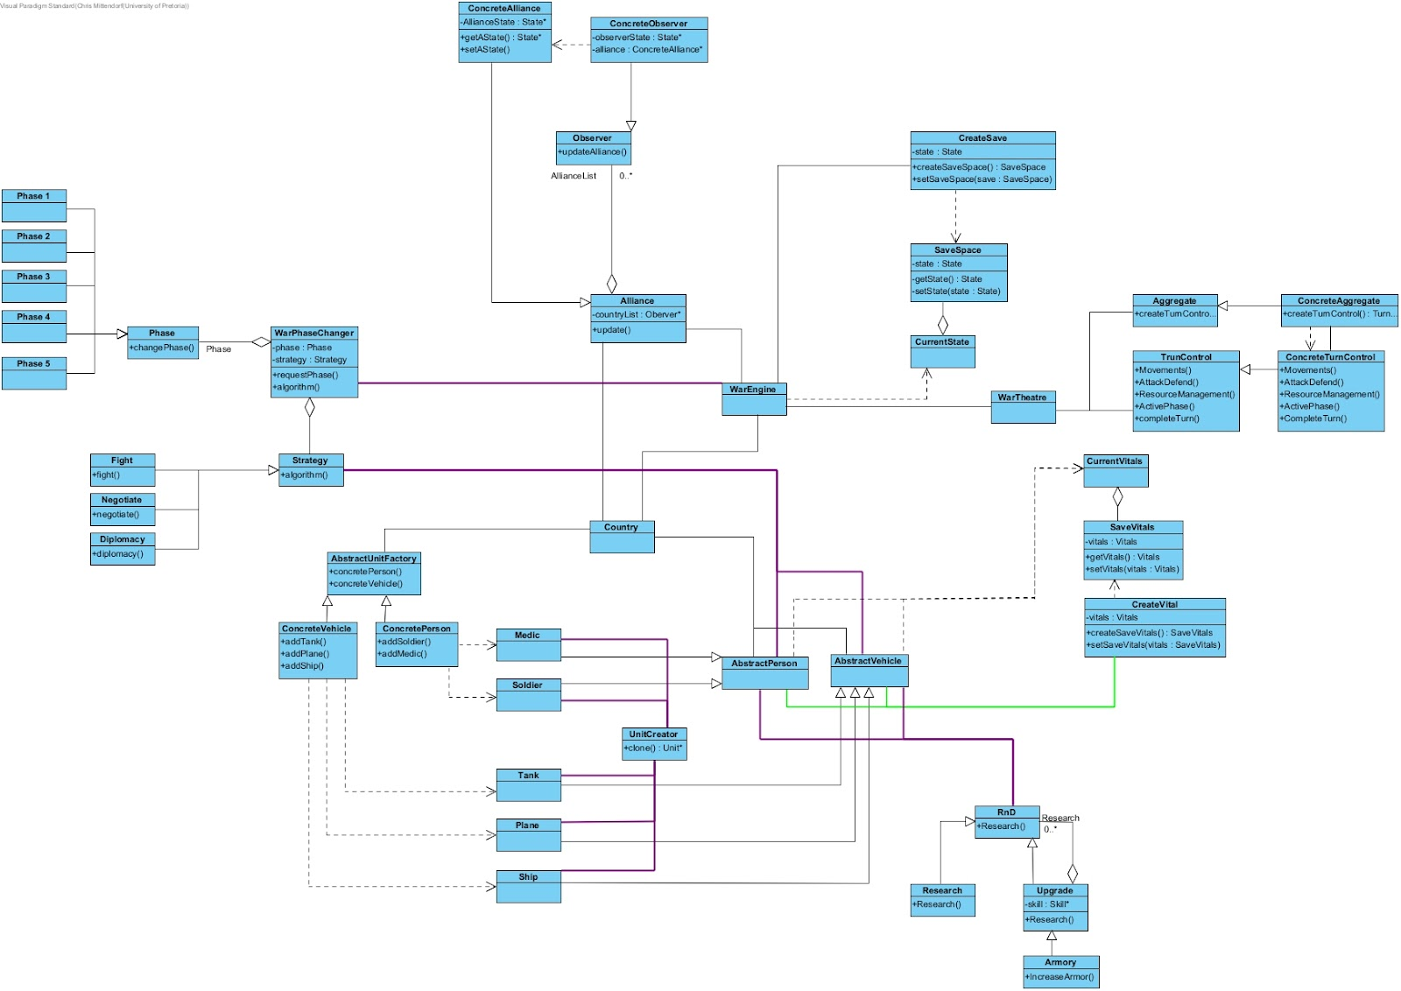

*Figure 8: Simulation Class Diagram*

References

[1] Gamma, E. *et al.* (1998) *Design patterns elements of Reusable Object Oriented Software*.

[2] Bloomfield, L.P. (1997) *Why Wars End: CASCON's Answers from History*. Available at: https://web.mit.edu/cascon/warend.html

[3] von Clausewitz, C. (1918) *On War*

[4] MasterClass (2022) *United Nations Explained: What Does the United Nations Do?* Available at: https://www.masterclass.com/articles/what-is-the-united-nations